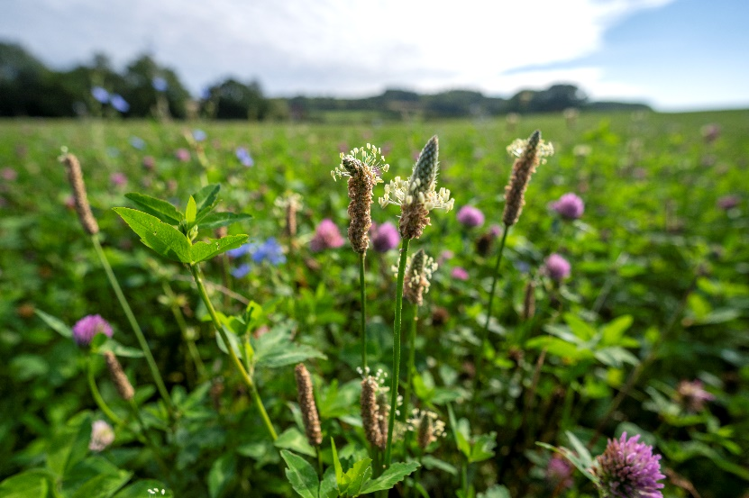

­­­­ [Grab your reader’s attention with a great quote from the document or use this space to emphasize a key point. To place this text box anywhere on the page, just drag it.]

**Job Title:** Project Ecologist

**Reporting to:** Head of

Sustainability

**Location:** Hatfield, Hertfordshire and Cranborne, Dorset

PROJECT ECOLOGIST CANDIDATE BRIEF

12 month fixed term contract

Gascoyne Estates manages 16,000 acres of rural land, including na­tive heath, chalk streams, forestry, grassland and arable. As a key part of our Sustainability Commitments, we are seeking to continuously improve the biodiversity and natural capital of our estates.

In order to monitor our approach, we are seeking an experienced ecologist to undertake a comprehensive natural capital baseline across our two rural estates.

Spending broadly equal time in both Hertfordshire and Dorset, the Project Ecologist will conduct detailed ecological surveys across our varied landscapes.

This data will be collected with a view to creating an estate scale habitat improvement plan, and the prospect of trading in emerging natural capital markets.

While the Project Ecologist’s primary focus will be on the completion of this baseline, they will also provide targeted support in ongoing biodiversity projects across the estates.

Working closely with our Estate Directors and rural teams, the

Project Ecologist will have excellent communication skills and be able to manage multiple stakeholders.

Working independently, they will also engage with tenants, farmers, foresters, gamekeepers and others in the delivery of their work.

This role will involve travel between the two estates as required. A travel and accommodation budget will be provided.

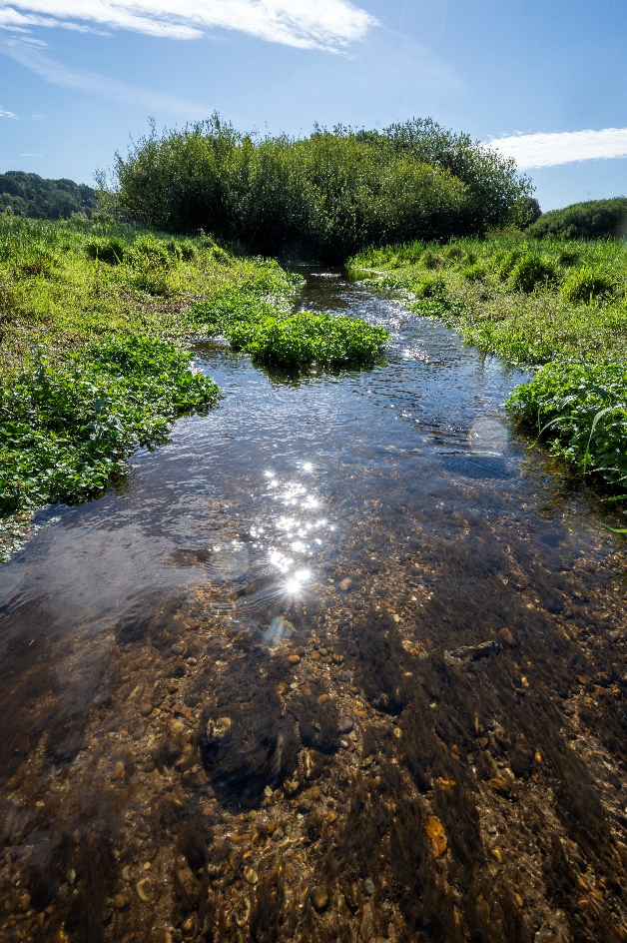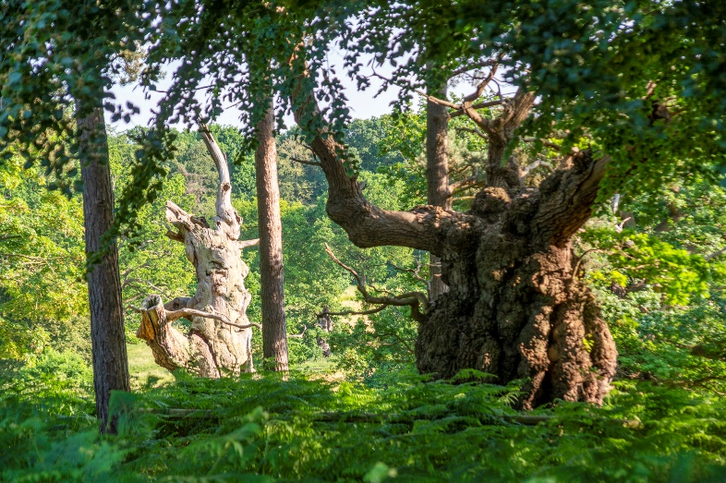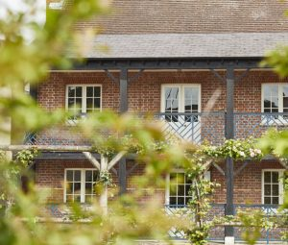

**Person**

* 5 or more years’ relevant experience
* Experienced, self-motivated and well organised.
* Comfortable managing relationships with multiple stakeholders, including tenants, owners, farmers, foresters and gamekeepers
* Able to work independently, but thrives as part of a team
* Adept at using established ecological methodologies, including UKHab and the DEFRA biodiversity metric
* Excellent verbal and written communicator
* A commercial mind, with an awareness of the key concepts of natural capital
* Competency with GIS tools and mapping software
* Passion for and knowledge of UK lowland biodiversity
* Full UK Driving License

**Main Responsibilities / Duties**

* Consolidation of existing biodiversity records
* Undertaking detailed ecological baseline surveys
* Report writing and communication of work to key stakeholders, verbally when required.
* Supporting ongoing projects with specialist advice
* Creation of GIS resources to assist in the interpretation of findings

**Key Deliverable**

* Creation of a comprehensive natural capital baseline for the Gascoyne rural estates

Please submit a CV and covering letter to Peter Mitchell at [p.mitchell@gascoyne.org](mailto:p.mitchell@gascoyne.org)

If you would like to discuss the role further, please email Peter at the above address to arrange a call.

Applications close on Friday 10th May with interviews taking place shortly thereafter.

